RS-2 Javelin
Specifications and assembly instructions
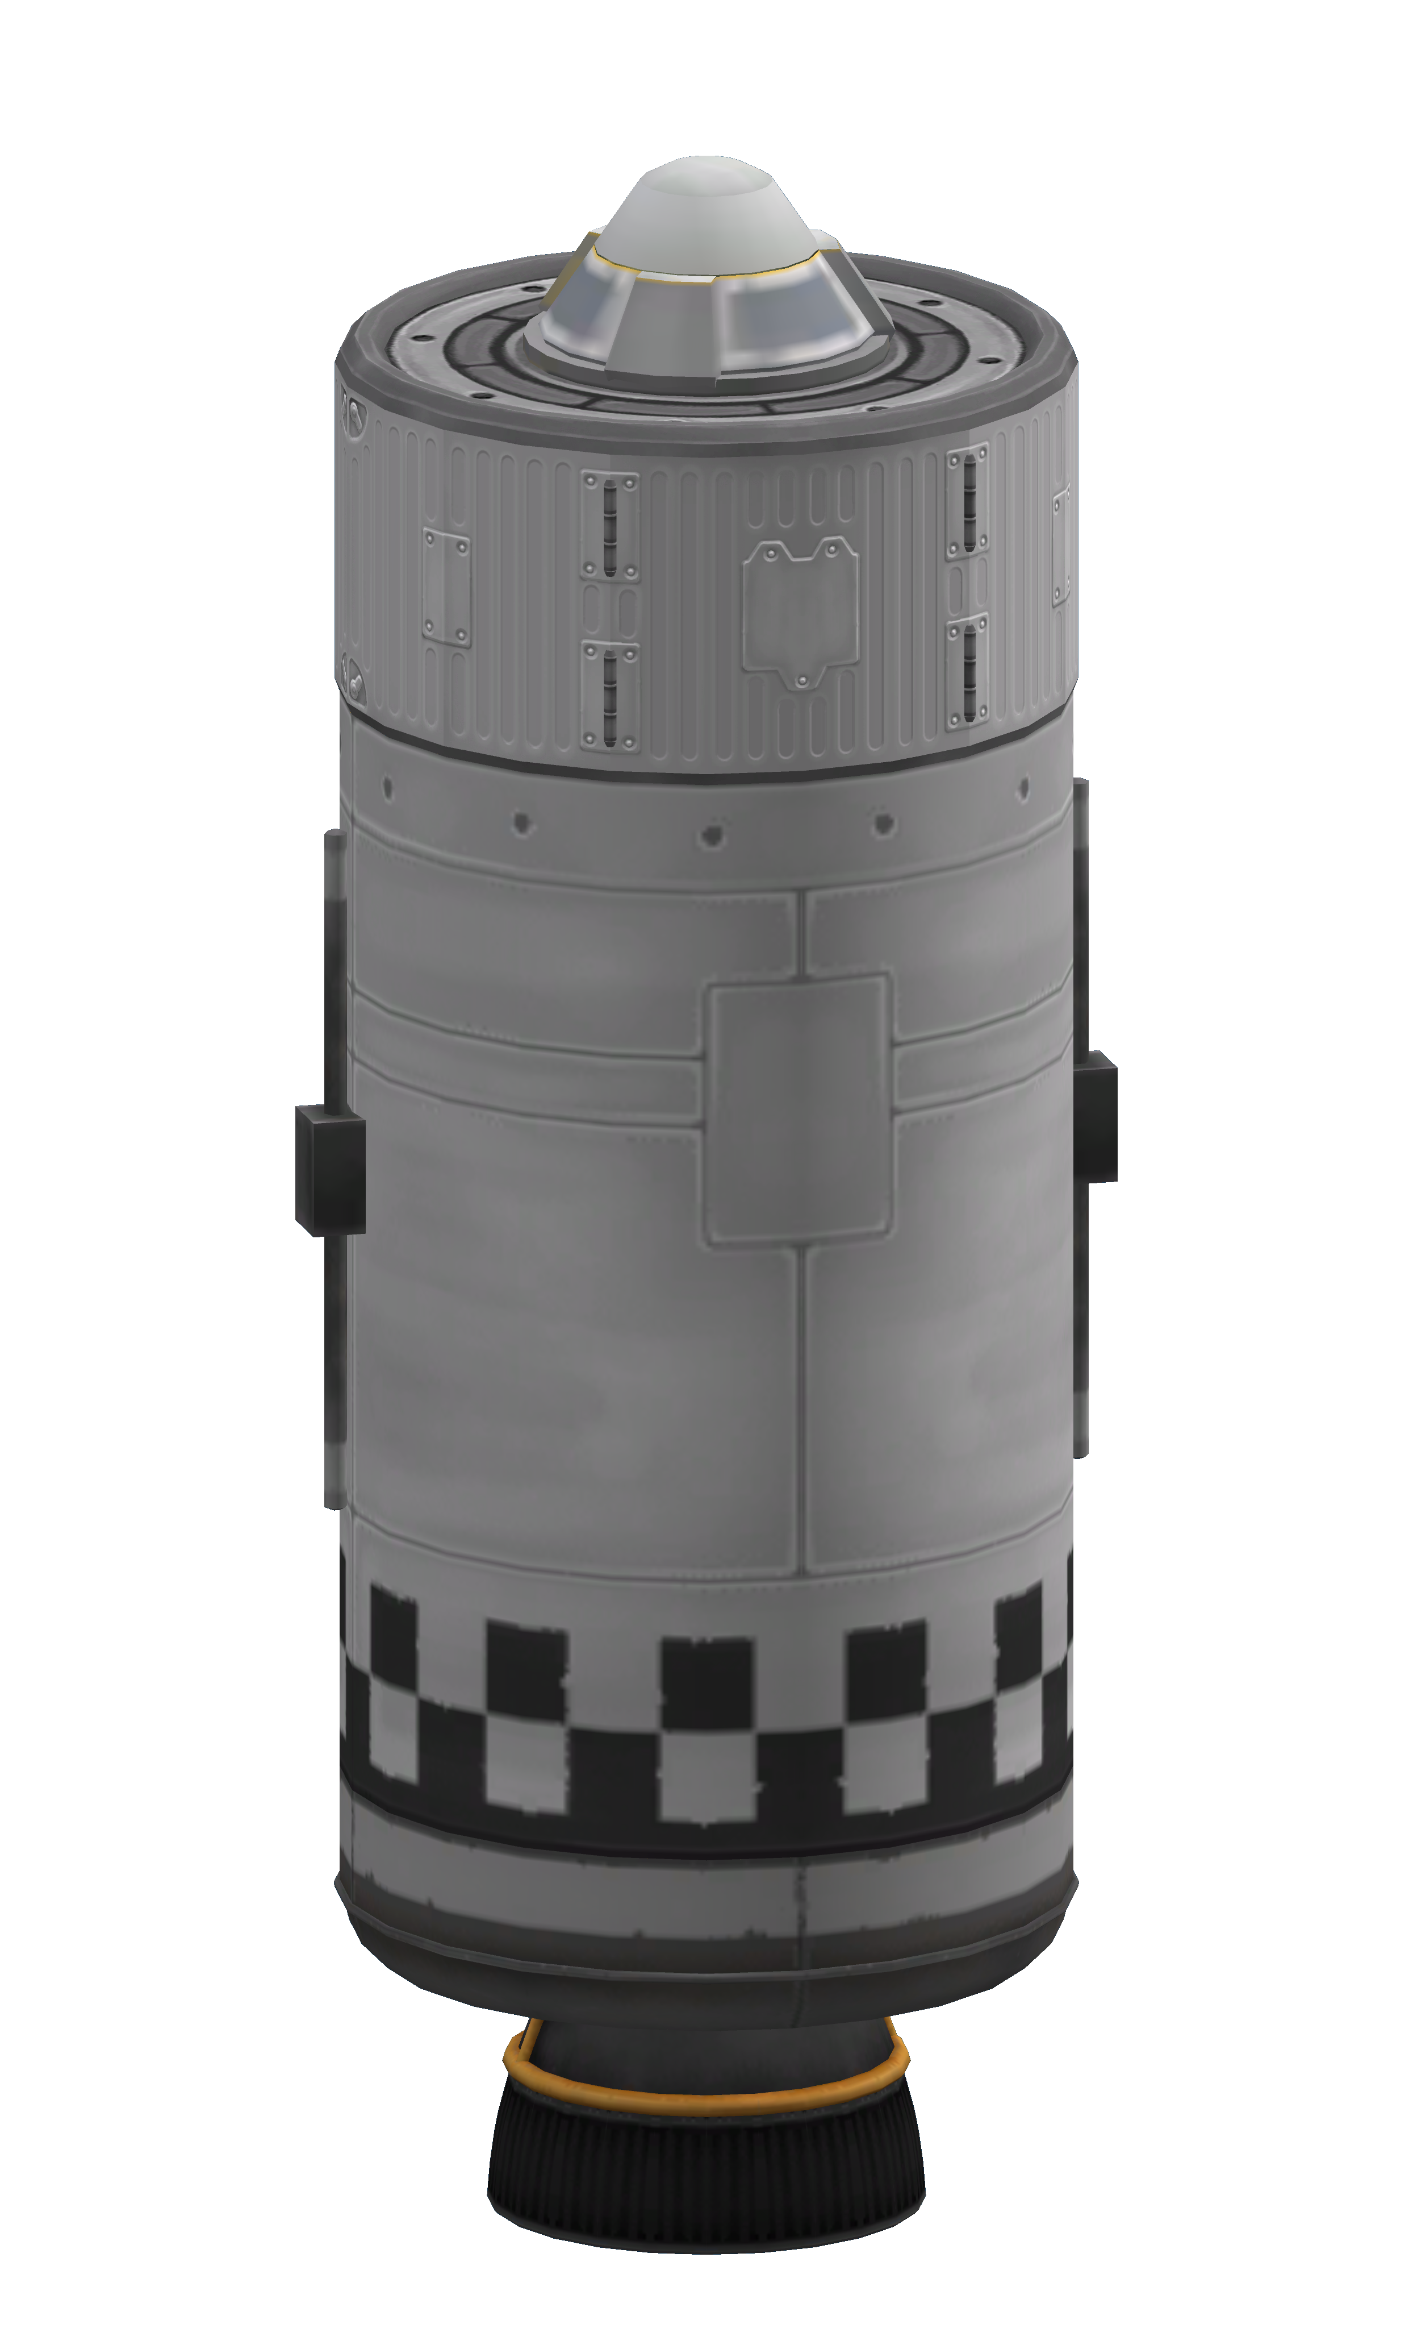

Description
The RS-2 Javelin stage is a high tech upper stage for orbital launches. The stage has its on board computer and is designed to insert payloads into low kerbin orbit. Once a payload is inserted, the stage can return to Kerbin on its own and be recovered using its parachutes.

Basic construction
Construction is best performed using two subassemblies. First, an avionics bay is built which houses computer, parachutes and batteries. Once this subassembly is built, the rest of the stage is mostly stacked axially.
There are two RS-2 variants: a regular one and an extended range version with an extra 100 unit LFOX tank. An interim variant with an OKTO computer can be built. These downgraded variants have the O suffix added to its model name.
Variant | Fuel amount
RS-2A | 400
RS-2B (aka RS-2 extended range) | 500

Command system
The stage has its own HECS on-board computer and redundant radios that enable it to fully control the launch process up to orbital insertion.

Guidance system
Guidance is provided by engine gimballing and assisted somewhat by the computer reaction wheel. Payload assistance is possible.

Recovery system
Stage recovery is provided by the parachutes. Full control is possible and hybrid parachute/propulsive landings can be achieved. Pure propulsive landings are not possible due to engine inefficiencies at sea level.

Assembly instructions
Use of prefabricated subassemblies is recommended but not necessary. Always store a set of savefiles for each variant.

Full bill of materials
1x Probodobodyne HECS (OKTO in downgraded models)
1x Z-200 Rechargeable Battery pack
1x Mk16 Parachute
1x FL-T400 Fuel Tank
1x FL-T100 Fuel Tank (ER model only)
2x Communotron 16-S
1x LV-909 "Terrier" Liquid Fuel Engine
1x Service Bay (1.25m)

Technology
The stage requires a technology level 5 with Precision Engineering (level 6) added. Derated versions of the stage can be created with pure level 5 technology.
- Precision Engineering
  - Probodobodyne HECS
- Electrics
  - Z-200 Rechargeable Battery pack
- Survivability
  - Mk16 Parachute
  - Service Bay (1.25m)
- Advanced Rocketry
  - FL-T400 Fuel Tank
  - LV-909 "Terrier" Liquid Fuel Engine
- Basic Rocketry
  - FL-T100 Fuel Tank (ER model only)
- Engineering 101
  - Communotron 16-S

Avionics bay

Parts list
1x Probodobodyne HECS (OKTO on downgraded models)
1x Z-200 Rechargeable Battery pack
1x Mk16 Parachute
1x Service Bay (1.25m)

Assembly procedure
Start with OKTO or HECS computer
Set Hibernate in warp to AUTO
Install Z-200 battery on axially on top of computer
Install parachute axially on top of battery
Set parachute parameters
Min pressure 0.45
Altitude 1250
Spread angle 0
Install payload bay so that lower part of computer is installed axially at bottom of bay
Match HECS/OKTO label to service bay door (E orientation)
Spare parts 0

Parameters
Part count: 4
Subassembly cost: 1942 (OKTO), (HECS)
Subassembly mass: 310 Kg (OKTO), Kg (HECS)

Final Assembly

Parts list
1x Avionics bay
1x FL-T400 Fuel Tank
1x FL-T100 Fuel Tank (ER model only)
2x Communotron 16-S
1x LV-909 "Terrier" Liquid Fuel Engine

Assembly procedure
Start with T400 tank.
Use dark "checkerboard" pattern.
Install communotron antennas radially on tank.
2x symmetry with snap
Vertical orientation
Antenna should barely touch "rivet ring" panel on top and checkerboard panel (but not checkerboard) at the bottom.
E/W orientation
Install LV-909 axially under tank.
On ER model, install T100 tank on top of T400 tank
Install avionics bay axially on top of uppermost tank
Doors oriented E/W
Re-root to service bay
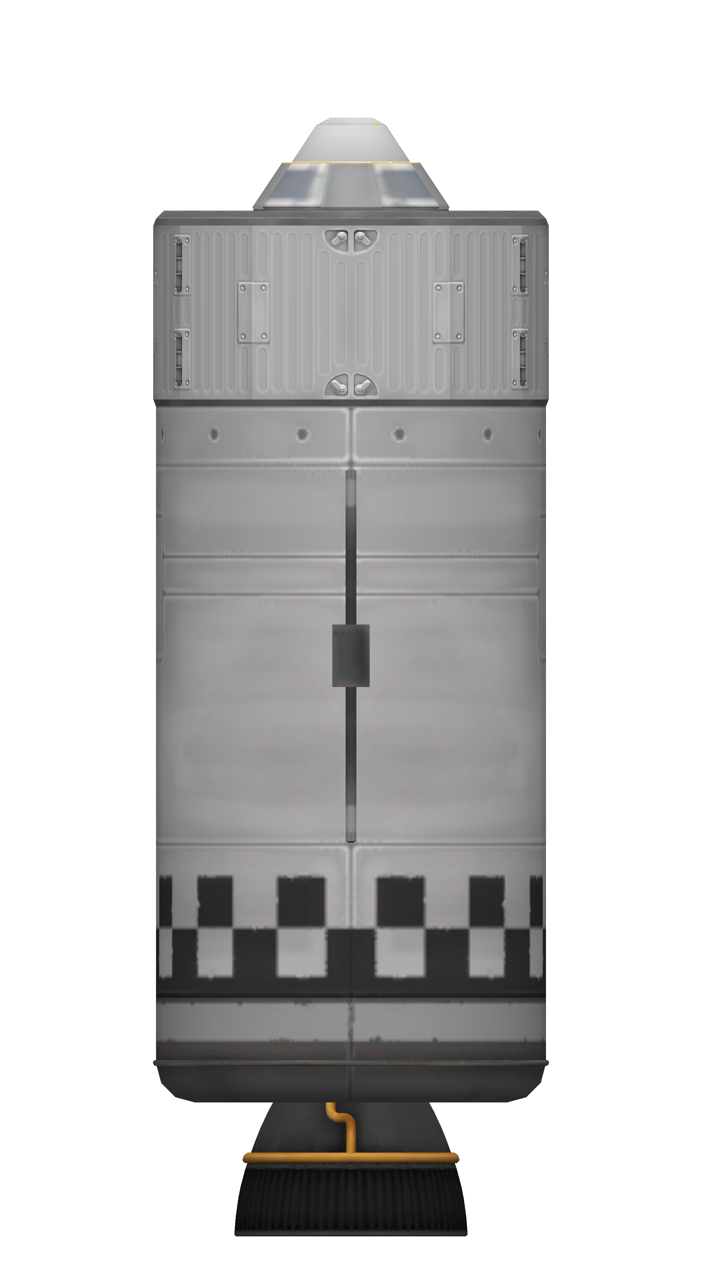Figure 1: Top view of RS-2A showing antenna placing

Stage configuration
Part | Variable | Value | Default | Notes
Parachute | Pressure | 0.45 | No
 | Altitude | 1250 | No
 | Angle | 0 | No
 | Mode | Safe | Yes
Service bay | Spare parts | 0 | No
 | Door | Closed | Yes | Close after inspecting items inside
Z-200 | Electric charge | FULL | Yes
Computer | Vessel naming | SET | No
 | Hibernation | Off | Yes
 | Hibernate in warp | Auto | No
 | Control point | Default | Yes
 | Reaction wheel | Normal/active | Yes
T100 tank | LFOX | FULL | Yes | B model only
 | Flow priority | -1 | No | B model only
T400 tank | LFOX | FULL | Yes
 | Flow priority | 0 | Yes
Radios | Retract/deploy | Active | Yes
 | Deactivate threshold | 20 | Yes
 | Activate threshold | 80 | Yes
Engine | Throttle | Main | Yes
 | Thrust limiter | 100 | Yes
 | Gimbal | 100/Free | Yes

Staging
Stage | Parts | Notes
0 | Parachutes
1 | Engine

Parameters
Model | A | AO | B | BO
Part count | 8 | 8 | 9 | 9
Cost (full) |  | 3432 |  | 3582
Cost (dry) |  | 3248 |  | 3353
Mass (full) |  | 3090 |  | 3653
Mass (dry) |  | 1090 |  | 1153

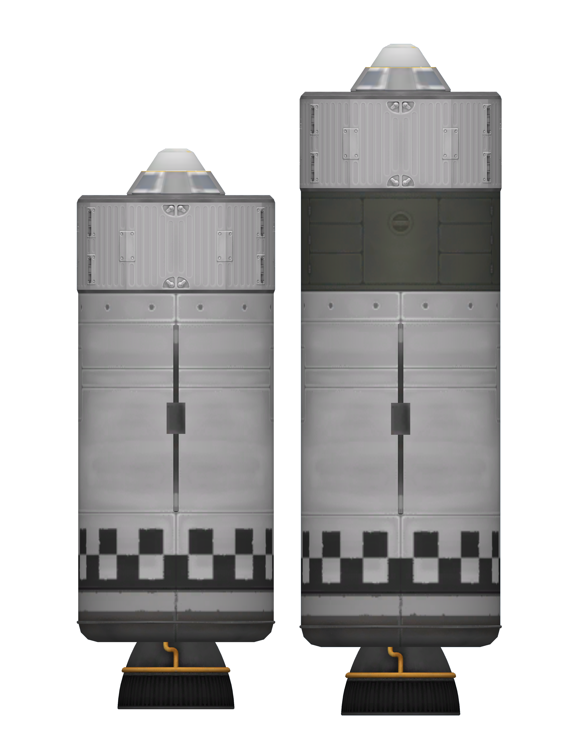Figure 2: RS-2 comparison, A model to the left, B model to the right

